**UNIVERSITY OF TRANSPORT AND COMMUNICATIONS**

**FACULTY OF INTERNATIONAL EDUCATION**

 

**GRADUATION PROJECT**

High-Quality Program of English - Vietnamese

Information Technology 2020 - 2024

Topic

**Build Ninja School Offline 2D game**

By

|  |
| --- |
| QUACH VAN DAI |
| Course 61  Class: Information technology V-E 2 |



**HANOI - JUNE 2024**

**UNIVERSITY OF TRANSPORT AND COMMUNICATIONS**

**FACULTY OF INTERNATIONAL EDUCATION**

 

**GRADUATION PROJECT**

Submitted in partial fulfillment of the requirements for the degree of engineer

|  |
| --- |
| High-Quality Program of English – Vietnamese  Information Technology 2020 - 2024 |

By

|  |
| --- |
| **QUACH VAN DAI** |

Supervisor: Dr. NGUYEN DUC DU

Working unit: Faculty of Information Technology, University of Transportation and Communications

Phone number: 0912.363.245

Email: nducdu@utc.edu.vn



**HA NOI - JUNE 2024**

**COMMENT OF SUPERVISOR**

1. **EVALUATION OF CONTENT AND QUALITY OF REPORT:**

1. **EVALUATION OF CONTENT AND QUALITY OF CODE//PROGRAMS:**

1. **EVALUATION OF WORKING ATTITUDE OF STUDENT:**

1. **CONCLUSION:**

1. **MARK:**

......................../10.

*Hanoi, June 2024*

MAIN SUPERVISOR

**COMMENT OF REVIEWER**

1. **EVALUATION OF CONTENT AND QUALITY OF REPORT:**

1. **EVALUATION OF CONTENT AND QUALITY OF CODE/PROGRAMS:**

1. **CONCLUSION:**

1. **MARK:**

......................../10.

*Hanoi, June 2024*

REVIEWER

# **THANK YOU**

I would like to express my gratitude to all the teachers in the Department of Information Technology - University of Transport and Communications, who have passed on their enthusiasm and knowledge to us during the last four years of school. passed by this school. The knowledge that teachers have imparted to us is priceless and will be our luggage throughout our lives!

I would like to express my deep gratitude to my teacher - Dr. Nguyen Duc Du, who wholeheartedly helped and guided me throughout the project implementation process. Your valuable instructions helped me complete the project in the best way possible!

I would like to thank the director and staff at Mobione telecommunications technology and service company limited., who have created conditions and stood by me from the time the topic was just an idea until it was completed. complete. Every help and suggestion from everyone is extremely valuable to me. Without that valuable support, I would not have been able to complete this project!

Finally, I would like to express my most loving feelings to my parents and the entire family, who have cared for, cared for, and raised me into the person I am today. Family is a solid support for children throughout the past years and the whole life ahead!

|  |  |  |
| --- | --- | --- |
|  |  | *Hanoi, June 2024*  Student  **Quach Van Dai** |

**THANK YOU** iii

**LIST OF PICTURE** v

**LIST OF ABBREVIATIONS** vi

**INTRODUCE** vii

CHAPTER I. OVERVIEW OF THE TOPIC 1

1.1 Introduction 1

1.1.1 Game market in Vietnam 1

1.1.2 Topic 1

1.2 Introduction to the development environment 1

1.2.1 Microsoft Visual Studio 2022 1

1.2.2 Outstanding features of Microsoft Visual Studio 1

1.2.3 C Sharp (C#) programming language 2

1.3 Unity Engine 3

1.3.1 What is Unity ? 3

1.3.2 Unity has had a major influence on the gaming industry and contributed significantly to its growth. 4

1.3.3 Basic concepts in Unity 5

**CHAPTER II. ANALYZE PROBLEMS AND DEPLOY APPLICATIONS** 9

2.1 Actual needs and requirements 9

2.2 Expected goal 9

2.3 Requirements analysis 9

2.3.1 System design analysis 9

2.3.2 Database 11

**CHAPTER III. USER INTERFACE DESIGN** 18

3.1 Deploy the application 18

3.2 How to play 18

3.2.1 Character moves 18

3.2.2 Character attack monster 18

3.3.3 The character uses the item. 18

3.2 Game design 19

3.3 Instructions for playing games on the website 30

**CONCLUSION** 32

**REFERENCES** 33

**LIST OF PICTURE**

Picture 1.Unity interface 4

Picture 2.Asset in Unity 5

Picture 3.Scene in Unity 6

Picture 4.Components in the Camera object 6

Picture 5.Create a new script file 7

Picture 6 Programming Unity using C# on Visual Studio 7

Picture 7. A script file is attached to the object 8

Picture 8. Main menu use case 9

Picture 9.Player move case 10

Picture 10.Player attack monster case 10

Picture 11. Monster Move case 10

Picture 12.Monster attack player 11

Picture 13.Set method 11

Picture 14. Get method 12

Picture 15. Food item 14

Picture 16. HP and MP items 14

Picture 17. Tile 15

Picture 18. Sprite 16

Picture 19. Audio Listener 17

Picture 20. The character the player controls 19

Picture 21. The character move 19

Picture 22. Level 1 skill 19

Picture 23. Level 5 skill 20

Picture 24. Level 10 skill 20

Picture 25. Level 15 skill 20

Picture 26. Level 20 skill 21

Picture 27. Npc principal 21

Picture 28. Mission panel 21

Picture 29. NPC food shop 22

Picture 30. Food shop panel 22

Picture 31. NPC herbal shop 22

Picture 32. Herbal shop panel 23

Picture 33. Scene game menu 23

Picture 34. Scene school 24

Picture 35. Scene templeA 25

Picture 36. Legendary village scenes 25

Picture 37. Ice mountain scene 26

Picture 38. Selection buttons 26

Picture 39. Luggage information panel 26

Picture 40. Mission information panel 27

Picture 41. Skill information panel 28

Picture 42. Player information 29

Picture 43. Setting panel 30

**LIST OF ABBREVIATIONS**

|  |  |
| --- | --- |
| NPC | Non-Player Character |
| HP | Health point |
| MP | Mana point |
|  |  |

# 

# **INTRODUCE**

**\* * * * \***

Welcome to the 2D ninja school game!

I am a fan of Ninja, a hero character who is half good and half evil, whose movements are mysterious but has extraordinary abilities.

Yes! We are so familiar with the world of Ninja, with unique and strange weapons, transformation techniques, mystical skills, and indomitable spirit.

We would like to introduce Ninja School, a historical role-playing game that will help you experience the Ninja world in the most vivid way. You play as a boy, you will decide your own Ninja path by joining an ancient school to practice.

Here, you will participate in training courses from teachers, personal tasks. Each character will have a unique personality, your practice and behavior in the game will make you unique.

Come join now and transform into a Ninja on the path to making a legend!

CHAPTER I. OVERVIEW OF THE TOPIC

1.1 Introduction

1.1.1 Game market in Vietnam

According to domestic and foreign experts as well as market research organizations, the development of a series of new technologies such as 5G, Blockchain, cloud computing... and strong improvements in online gaming equipment hardware (PC, smartphone) in recent times has helped Vietnam rapidly increase the number of game players, increase revenue and profits and opportunities to participate in the online gaming industry of companies around the world.

In addition, seizing opportunities in the world's game industry development trend, game production and publishing companies in Vietnam have taken advantage of abundant, high-quality human resources to focus on developing their products. Developing games in genres such as: Mmorpg (multiplayer online role-playing game), Turn base (turn-based tactical battle game), Moba (multiplayer online arena game), Casual (game popular, simple), SLG (strategy simulation game), RPG (role-playing game)...

### 1.1.2 Topic

From the above analysis, during the time studying knowledge at school combined with graduation internship, I used my little knowledge to learn and analyze the problem "Building a Ninja school Offline game application 2D”.

## 1.2 Introduction to the development environment

### 1.2.1 Microsoft Visual Studio 2022

Microsoft Visual Studio is an integrated development environment (IDE) designed for programmers and application developers. This is Microsoft's powerful software development support tool, allowing users to write, compile and debug applications based on many different programming languages ​​such as C++, C#, Visual Basic, Python, JavaScript. .. Visual Studio includes a source code editor, debugging tools, and cross-platform application building. It helps increase productivity and work efficiency for programmers.

### 1.2.2 Outstanding features of Microsoft Visual Studio

**+ Cross-platform support:** Visual Studio is available on Windows, macOS and Linux, allowing you to use it on any operating system you like.

**+ Multi-language support:** Microsoft Visual Studio stands out with its ability to support a wide range of programming languages, including JavaScript, TypeScript, Python, C#, Java, Go, Ruby... This makes it The ideal tool for developers working on multiple projects in multiple programming languages. In addition, Microsoft Visual Studio's multi-language support also helps programmers easily switch between languages ​​and projects without having to change their working environment, thereby saving time and money. time to optimize work efficiency.

**+ Powerful debugging support: Microsoft Visual Studio provides a powerful debugging support system with features such as Breakpoints, variable inspection, step-by-step code tracking and debugging console. These tools will help developers easily find and fix errors in source code, increasing the efficiency and quality of the software development process. In addition, Microsoft Visual Studio's debugging toolset will also help reduce the time and effort required to identify and fix problems in code, thereby speeding up application development and deployment.**

**+ Git integration: Another standout feature of Microsoft Visual Studio is its support for Git, allowing developers to manage versions directly in the editor. Thanks to that, source code management will become easier and more effective thanks to the ability to perform Git operations such as commit, push, pull and view source code history very intuitively. Besides, Git integration also helps Microsoft Visual Studio optimize developers' workflow, ensuring they can focus on writing and improving code instead of version management.**

**+ Automatic code completion (IntelliSense): Microsoft Visual Studio also provides IntelliSense feature - an intelligent source code auto-completion system based on context. Basically, IntelliSense will display hints about variables, methods and other elements of the source code, helping to speed up the coding process. As a result, this feature not only helps increase productivity by reducing the time spent typing code, but also helps reduce errors and provides useful information about APIs and libraries that developers may not be familiar with. belong. With IntelliSense, Microsoft Visual Studio will certainly be an intelligent assistant to assist developers in writing code more quickly and accurately.**

Microsoft Visual Studio has truly become one of the most popular and widely used code editors, embraced by the software development community worldwide. It combines consistency, scalability, and powerful performance to deliver the best code development experience for developers.

### 1.2.3 C Sharp (C#) programming language

#### 1.2.3.1 Introduction

C# (or C sharp) is a simple programming language, developed by Microsoft's engineering team in 2000. C# is a modern, object-oriented programming language and is built on the foundation of two The most powerful languages ​​are C++ and Java.

In traditional Windows applications, the program source code is compiled directly into the operating system's executable code.

In applications using the .NET Framework, the program source code (C#, VB.NET) is compiled into MSIL (Microsoft intermediate language) code.

This code is then compiled by the Common Language Runtime (CLR) to become the operating system's executable code. The figure below shows the process of converting MSIL code into native code.

C# with strong support of .NET Framework makes creating a Windows Forms or WPF (Windows Presentation Foundation) application, game development, Web application, Mobile application very easy.

#### 1.2.3.2 ****Features of C# programming language****

**+ C# is a simple language it eliminates some of the complexity and complexity of languages ​​like Java and C++, including eliminating macros, templates, multiple inheritance, and virtual base classes. class).**

**+ C# language is simple because it is based on C and C++. If we are familiar with C and C++ or even Java, we will find C# quite similar in appearance, syntax, expressions, operators and other functions taken directly from C and C++ languages, but it has been improved to make the language simpler.**

**+ C# is a modern language: Features such as exception handling, automatic memory collection, extensible data types, and code security are expected in a modern language. C# contains all the above features. If we are new to programming, we may find the above features complicated and difficult to understand. However, don't worry, we will gradually learn the features through the content of this course.**

**+ C# is a purely object-oriented programming language : Object-oriented programming (OOP: Object-oriented programming) is a programming method with four characteristics. These are abstraction, encapsulation, polymorphism and inheritance. C# supports us with all of the above features.**

**+** **C# is a low-keyword language**

**+ C# is a language that uses limited keywords. The majority of keywords are used to describe information. We might think that a language with a lot of keywords is stronger. This is not true, at least in the case of C#, we can find that this language can be used to do any task.**

## ****1.3 Unity Engine****

### 1.3.1 What is Unity ?

**Unity** is a cross-platform game engine and application development environment. It provides a wide range of tools and features for creating games, virtual reality (VR), augmented reality (AR), and other interactive applications across multiple platforms, including mobile devices. computers, cell phones, game consoles.

**Unity development:** First launched in 2005 at Apple's Worldwide Developer Conference by founder David Helgason, after more than 12 years of development, Unity now has version 5.5 that is more complete in many aspects. In May 2012, according to the Game Developer survey, Megazine was recognized as the best game engine for mobile. In 2014 Unity won "Best Engine" at UK's annual Develop Industry Exellence .

**Some important features of Unity**

**+ Cross-platform: Unity allows developers to create apps for a variety of platforms, including iOS, Android, Windows, macOS, Linux, and more.**

**+ Graphics and effects:** Unity provides a powerful graphics system with the ability to handle 3D and 2D graphics. It supports special effects such as lighting, shadows, and particle effects.

**+ Physics Engine**: Unity integrates a powerful physics engine, allowing developers to simulate physical reactions such as collision, gravity, and friction.

**+ Audio Engine**: Unity provides a flexible audio system, allowing developers to add and control audio, background music, and sound effects in their games.

**+ Collaboration and version management:** Unity supports collaboration features that allow multiple developers to work on the same project simultaneously. It also provides version management tools to track and manage project versions.

**+ Community and resources:** Unity has a large and active community, providing learning materials, forums, and other resources to support developers.

+ **Virtual Reality and Augmented Reality:** Unity supports virtual reality and augmented reality app development through technologies like Unity XR, helping developers create new interactive experiences.

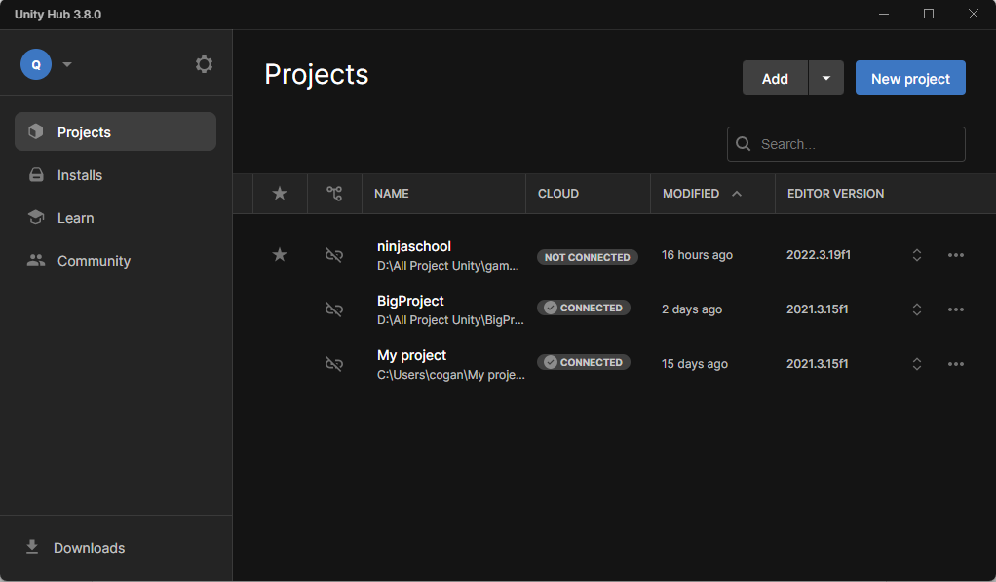

Picture 1.Unity interface

### 1.3.2 Unity has had a major influence on the gaming industry and contributed significantly to its growth.

**+ Unified development platform:** Unity provides a unified game development platform for developers, helping them focus on creating fun games instead of worrying about cross-platform compatibility different.

**+ Save time and costs:** Unity offers a wide range of time-saving tools and features for game development, from drag-and-drop tools to resource availability in the Asset Store. This helps reduce development costs and time to market.

**+ Cross-platform capabilities:** Unity allows developers to develop games for many different platforms with ease, from computers to mobile phones, consoles, and even physical devices virtual and augmented reality.

**+ Large community support:** Unity has a large community, full of learning resources, knowledge exchange forums, and documentation, helping developers share ideas and answer questions. and support each other.

**+ Integrating new technologies:** Unity continuously updates and integrates new technologies such as artificial intelligence, augmented reality, virtual reality, and machine learning into its platform, helping developers create Fresh and innovative games and experiences.

### 1.3.3 Basic concepts in Unity

##### 1.3.3.1 Asset

This is a resource store for building games in a Unity project. These resources can be images, sounds, or an existing 3D model. Unity will refer to the files we will use to create the resources for the game. This is why in any folder containing a project using Unity, all asset files must be stored in a subfolder called Assets.

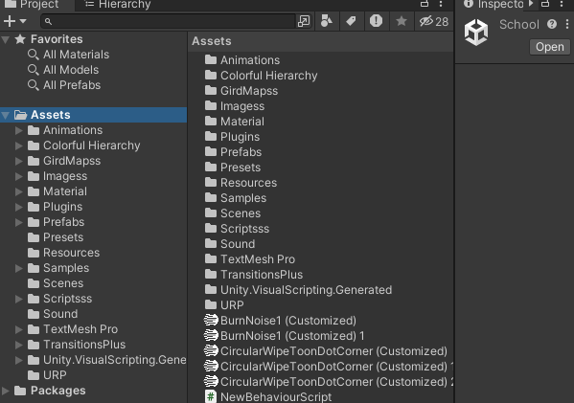

Picture 2.Asset in Unity

##### 1.3.3.2 Scene

In Unity, we can think of Scenes as individual stages, levels, or regions of game content. For example, Main menu, Options, About...

By building the game with multiple scenes, we will be able to distribute load times and test different parts of the game individually quickly and accurately.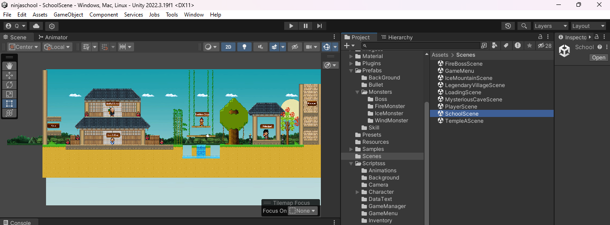

Picture 3.Scene in Unity

##### 1.3.3.3 Game windown

This is the Game demo screen, which is the view from the camera in the game.

The toolbar in the game window provides customizations of screen resolution, stats, gizmos, the option to toggle components ...

##### 1.3.3.4 Gameobject

When a resource is used in a scene, we can then consider this resource as a new “Game Object”. Each GameObject must contain at least one component, which is the “Transform” component. Transform contains operations to change the rotation angle, scale or translation of an object. From here on in this report we will call the GameObject in the Hierarchy window the game object.

##### 1.3.3.5 Component

Components are components in a Unity Game Object. By attaching components to an object, we can immediately apply new parts of the game engine to the object. Usually these components are pre-built by Unity such as lighting, camera, particles, physical effects...

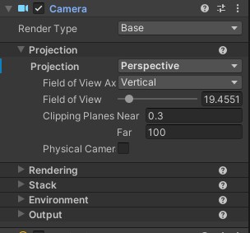

Picture 4.Components in the Camera object

##### 1.3.3.6 Script

Script is the most important component in Unity, scripts can be seen as the soul of the game. We can write game scripts using C#, Java Scripts, or Boo (a derivative of the Python language). According to many people who have used Unity, coding in C# will help the game run faster and help control the code better because all variables must be clearly declared. On the other hand, C# language is very convenient for programming, so in this thesis, we use C# language to write scripts for games. Each C# script file is a mandatory class that inherits from the MonoBehaviour class, whose class name must match the script file name. 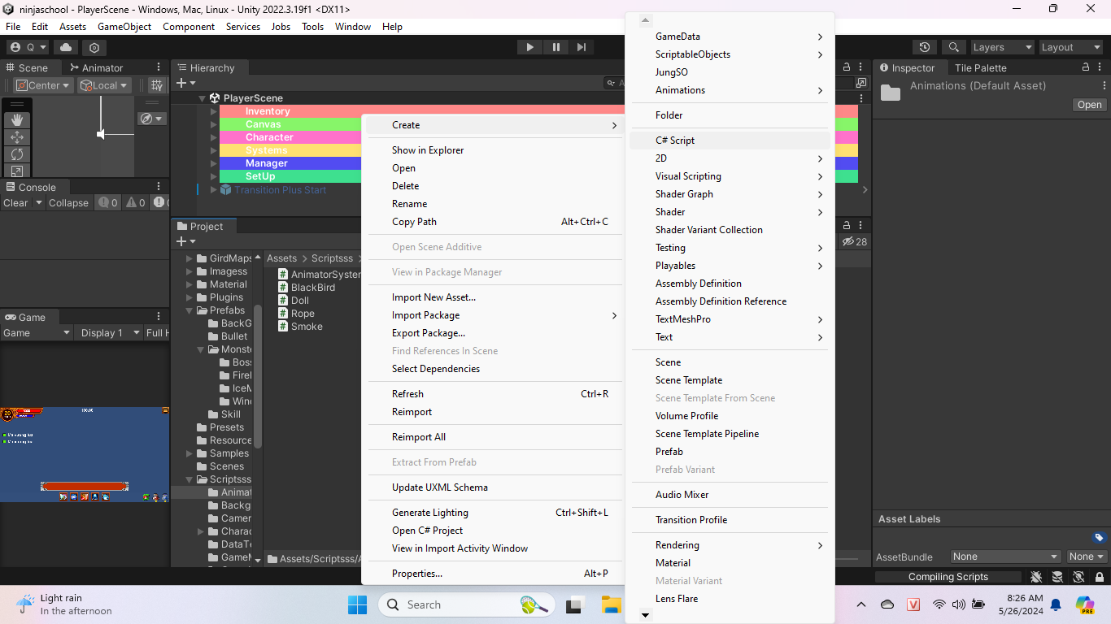

Picture 5.Create a new script file

The C# code interface is very familiar when editing on Visual Studio 2022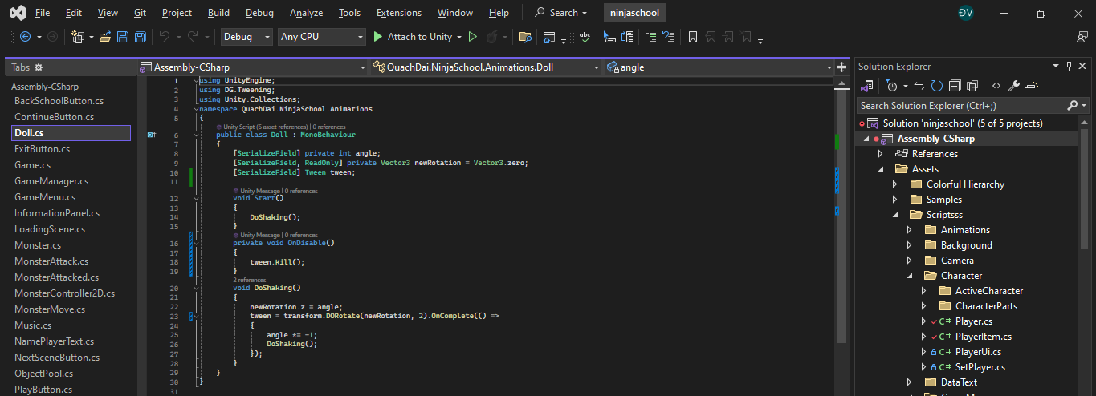

Picture 6 Programming Unity using C# on Visual Studio

For a script to be executed, it must be attached to an object.

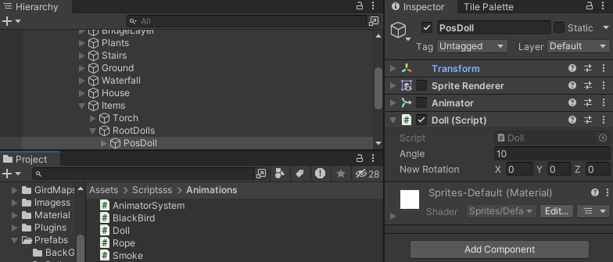

Picture 7. A script file is attached to the object

##### 1.3.3.7 Prefab

As a concept in Unity, it is used to reuse the same objects present in the game by simply reconstructing the position values, distortion ratio, and rotation angle from the original object. For example: The objects that are coins in the Mario game all have the same treatment, so we just need to create an initial object, the remaining coins will use prefabs. Or when we lay tiles for a floor, the tiles are also used as prefabs

##### 1.3.3.8 Transform

Are 3 translational transformations, rotating along axes, and zooming in and out of an object.

##### **1.3.3.9 Hierarchy window**

The hierarchy tab is where the current Sence Game Objects are displayed. When objects are added or deleted in Sence, they correspond to those objects in the Hierarchy window.

Similarly in the Project tab, Hierarchy also has a search bar that helps manage and manipulate Game Objects more efficiently, especially for large projects.

##### 1.3.3.10 Windows Inspector

The Inspector window displays detailed information about the working game object, including the attached components and its properties. You can adjust and set all parameters and functions of the Game Object through the Inspector window.

Every property shown in the Inspector can be easily customized directly without going through a predetermined script. However, the Scripting API provides a greater number and completeness because the Inspector interface is limited.

The settings of each component are located in the menu. You can right-click, or select the small gear icon to appear the menu.

In addition, the Inspector also shows all Import Setting parameters of the working asset such as displaying the source code of the Script, animation parameters, ...

# **CHAPTER II. ANALYZE PROBLEMS AND DEPLOY APPLICATIONS**

## 2.1 Actual needs and requirements

**+ Entertainment, stress relief:** One of the main needs of players is to find a game that brings entertainment and helps relieve stress after a busy day. NinjaSchool 2D game can provide an attractive and interesting environment for players to relax and entertain.

**+ Challenge:** Players often look for significant challenges in games. NinjaSchool 2D game can provide complex terrain that requires players to use problem-solving skills, find solutions and react quickly to overcome obstacles. When players successfully complete a difficult terrain, they will feel a sense of accomplishment and satisfaction with their abilities.

**+ Diversify the experience:** Practical requirements also include providing variety in gameplay. NinjaSchool 2D games can offer varying levels of difficulty, randomly generated terrain, or even include accompanying adventure and plot elements to increase excitement and exploration for players..

**+ Convenient and accessible:** Games need to be developed to meet the needs of a diverse player base. This means the game must have a user-friendly interface that is easy to use.

## 2.2 Expected goal

* Successfully built games on the Windows platform
* Successfully build some main functions: Missions, buying and selling items, controlling characters, etc.
* Successfully built the map.
* Successfully built artificial intelligence for monsters.

## 2.3 Requirements analysis

### 2.3.1 System design analysis

* **Use cases:**

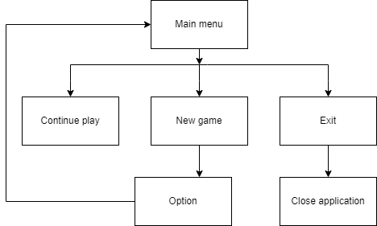

Picture 8. Main menu use case

* **Player move case**

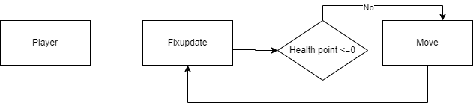

Picture 9.Player move case

* **Player attack monster case**

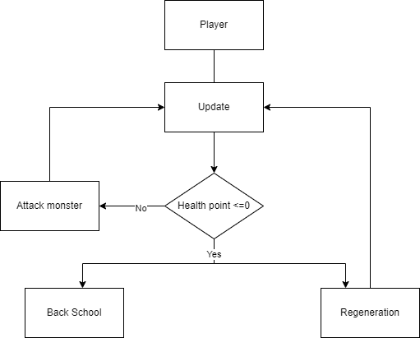

Picture 10.Player attack monster case

* **Monster Move case**

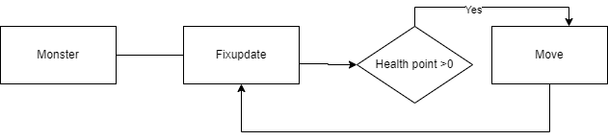

Picture 11. Monster Move case

* **MonterAttack case**

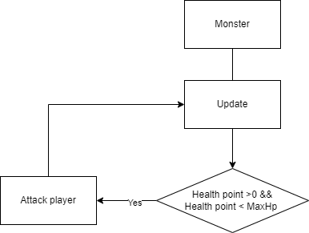

Picture 12.Monster attack player

### 2.3.2 Database

PlayerPrefs is a built-in class in Unity that provides an easy and natural way to store and retrieve values. It can be used to store data such as user preferences, game progress, high scores, or any data you want to maintain even after the game has been closed.

PlayerPrefs: allows you to store string, float, and integer values ​​in the user's registry.

DeleteAll : Delete all keys and values ​​from PlayerPrefs.

DeleteKey : Delete specific key from PlayerPrefs.

GetFloat : Returns the value corresponding to the key if it exists.

GetInt : Returns the value corresponding to the key if it exists.

GetString : Returns the value corresponding to the key if it exists.

Save: Saves all changes to PlayerPrefs.

SetFloat: Sets the float value for the given key.

SetInt: Sets the integer value for the given key.

SetString: Sets the string value for the given key.

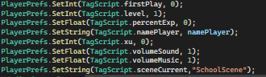

Picture 13.Set method

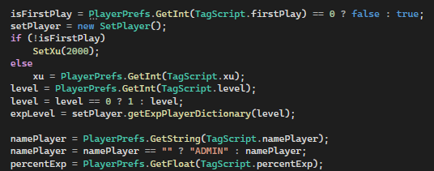

Picture 14. Get method

##### 2.3.3 Game overview

* **Game genre**:Game Platform 2D ,role-playing, action, adventure.
* **Game Mode(Single or Multi):** Single player.
* **Level:** Easy and average
* **Suitable players:** Players over 6 years old .
* **Game Play :** Players will take on the role of characters in the game. To increase their strength, players will have to diligently do tasks from the principal. To complete the mission, players must go through difficult terrain challenges and monsters.
* **Detailed information in the game**

**+ Character:** the player controls

**+ Character name**: players will choose their own favorite name.

**+ Level:** from level 1 to level 20.

**+ Attack:** the amount of damage dealt increases according to level.

**+ HP:** maintains life.

**+ MP:** used to use skills.

**+ Skills:** there are 5 skills, skills will be unlocked at levels 1, 5, 10, 15, 20.

**+ Level 1 skill:** Used to attack monsters.

**+ Level 5 Skill:** Used to support the character in increasing Hp ,MP.

**+ Level 10 skill:** Used to attack monsters.

**+ Level 15 skill:** Used to attack monsters with large amounts of damage.

**+ Level 20 skill:** Used to attack monsters.

**+ Luggage:** Used to store items such as HP bottles, MP bottles, food,

**+ Headmaster**: the player accepts the mission.

**+ Food Shop:** players buy food items.

**+ Herbal shop:** players buy Hp and Mp potions.

**+ Monsters:** There are 2 types of monsters: flying monsters and ground monsters.

**Monster information:** name, level, hp, damage,

|  |  |  |  |
| --- | --- | --- | --- |
| **Image** | **Name** | **Level** | **Environment** |
|  | IceDevil | 1 | Ground |
|  | Snow wolf | 2 | Ground |
|  | Carnivorous Flower | 3 | Ground |
|  | Devil Herbs | 4 | Ground |
|  | Green Dragon | 5 | Fly |
|  | Green Snake | 6 | Ground |
|  | Green Toad | 7 | Ground |
|  | Monkey | 8 | Ground |
|  | Pterosaurs | 9 | Fly |
|  | Fire Bat | 10 | Fly |
|  | Fire Demon King | 11 | Fly |
|  | Fire Scorpion | 12 | Ground |

Table 1. Monsters

**+ Setting:** Has the function of adjusting sound and exiting the game.

* **Items**



Picture 15. Food item

** **

Picture 16. HP and MP items

2.3.4 Game building concepts

* + - 1. **Tile**

A "tile" refers to a small-sized image, often a bitmap, typically square or rectangular in shape. The length of the tile's edges (measured in pixels) is usually a divisor of the screen's frame or window.

Large images in games are composed of smaller tiles. Breaking down these larger images into smaller tiles is advantageous for storage and flexibility in creating various graphical elements within the game. It helps save a significant amount of memory and improves program speed by optimizing image loading times.

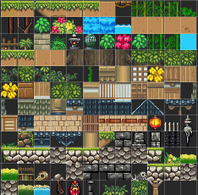 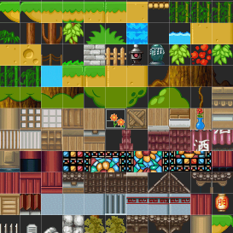

Picture 17. Tile

With such advantages, tiles are commonly used in creating maps for 2D games. By using tiles, game developers can efficiently construct and arrange different components of the game world, such as terrain, objects, and obstacles. The modular nature of tiles allows for easy editing and rearrangement of the game map, providing flexibility and saving development time. Additionally, tiles enable the efficient rendering of game environments, as only the visible tiles need to be displayed, optimizing performance and memory usage.

* + - 1. **Sprite**

A sprite, unlike a tile, is a complete image of an object. Each animated object has its own set of corresponding sprites for different motion states, where each sprite represents a specific frame within that motion. By continuously changing these sprites with an appropriate delay between them, a sequence of moving images is created, giving the illusion of motion. Moving visuals commonly seen in games, particularly in 2D games, such as character movements, enemy movements, attacks, etc., can be represented using sprites.

Sprites are used to animate objects and bring them to life in the game world. By displaying different sprites in a specific sequence, game developers can create smooth and dynamic animations for various actions and motions. This technique adds visual appeal, realism, and interactivity to the game, enhancing the overall gaming experience.

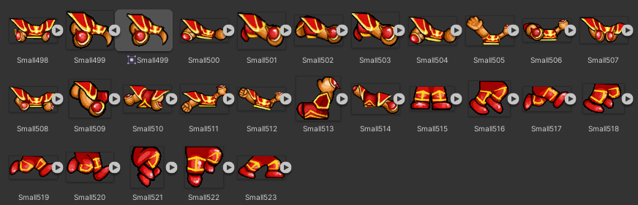

Picture 18. Sprite

**2.3.4.3 Frame**

All display devices for motion images today, such as TVs, monitors, etc., rely on the human eye's ability to retain images. After an image disappears, our eyes can still retain it for about 1/24th of a second in the retina. Therefore, to create films, people simply need to continuously change images at a speed of 24 frames per second or higher. This technique is also applied in games to create motion, and each screen update is referred to as a frame.

* + - 1. **Collision detection**

Collision detection is an essential part of games, and the level of complexity in handling collisions can vary depending on each game's requirements. For games built on tiles with the same size and coordinates measured in sprites, collision detection can be relatively straightforward. It involves checking the coordinates of the sprites of two objects to determine if they occupy the same tile. However, for games with sprites of different sizes, collision detection can be based on the coordinates and dimensions of the sprites to determine if they overlap, indicating a collision.

* + - 1. **Canvas**

In Unity, Canvas is an important component of the UI (user interface) system and it acts as a framework to organize and display user interface elements such as buttons, text, images, and many other ingredients. Each UI element in Unity must reside within a Canvas to be displayed on screen.

* + - 1. **Animation**

Sprite animations are animated clips created for 2D content. There are many different ways to create Sprite Animations. One way is to create them from a Sprite Sheet, a collection of Sprites arranged in a grid. The Sprites will then be compiled into an Animated Clip that will play each Sprite to create animation, like a flipbook. Sprite animations can also be created using keyframe animations in Unity, through the Animations window.

* + - 1. **Audio**

**Audio** in Unity is an important part of creating the in-game audio experience.

**Audio Source:** is an object attached to a GameObject for audio playback. Each object that wants to play sound needs an Audio Source.

**Audio Clip:** This is the audio file that will be played back. Unity supports audio file formats like .wav, .mp3 etc.

**Some methods and properties related to Audio Source:**

**Method**:

Play: Play an Audio Clip. You can use Play to start playback of a sound from a script.

Pause: Pause audio playback.

Stop: Stop playing sound.

PlayOneShot: Play an Audio Clip without affecting other sounds being played. This method is often used to play short sounds, like gunshots or footsteps.

**Properties:**

Volume: Adjust the volume of the Audio Source while playing.

Loop: allows the sound to repeat or not.

**Audio Listener** is the audio receiving component, usually attached to the Main Camera in the game. Each scene should only have one Audio Listener to avoid conflicts.

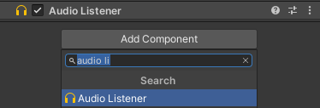

Picture 19. Audio Listener

**CHAPTER III. USER INTERFACE DESIGN**

## 3.1 Deploy the application

I am a fan of Ninja, a hero character who is half good and half evil, whose movements are mysterious but has extraordinary abilities. Here, you will participate in training courses from teachers, personal tasks or do them with friends. Each character will have a unique personality, your practice and behavior in the game will make you unique.

Control functions include: left, right arrow keys, up space key to use skills. The program will have background music during the game, and sounds when using skills.

## 3.2 How to play

### 3.2.1 Character moves

Players use the navigation keys ← ↑ → to move the character as desired.

3.2.2 Character attack monster

The player wants to attack a certain monster. First, you need to select that monster (note that if the monster is too far away, you won't be able to click). Next, the player checks to see if they have set the correct skill to attack monsters (skill levels 1, 10, 15, 20 can attack monsters).

After completing the above 2 steps, the player presses the Space key to attack the monster.

3.3.3 The character uses the item.



To use food, players can directly click on the icon or key E. (Note that the inventory must exist. If it runs out, you can go to the store to buy it).



To use HP potions, players can directly click on the icon or the R key. (Note that the goods must be available, if they run out you can go to the store to buy).



To use MP potions, players can directly click on the icon or the T key. (Note that the goods must be available, if they run out you can go to the store to buy).

## 3.2 Game design

**Characters:** To create a complete character, I use many small pieces and put them together.

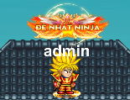 ** **

Picture 20. The character the player controls

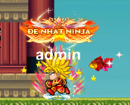

Picture 21. The character move

**Level 1 skill:** Elementary skills. The skill calls for Loi Ma Phong Van to strongly attack the enemy.

 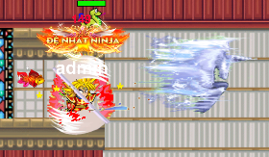

Picture 22. Level 1 skill

**Level 5 skill:** Support skills. This skill helps you increase your Hp and MP for a period of time.

 

Picture 23. Level 5 skill

**Level 10 skill:** Ice-type skills. The skill calls on the powerful Ice Tiger to strongly attack the enemy.

 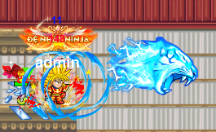

Picture 24. Level 10 skill

**Level 15 skill:** The skill calls for powerful lightning to attack enemies.

 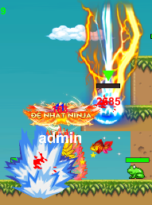

Picture 25. Level 15 skill

**Level 20 skill :** Fire-type skills. The skill calls on the powerful Fire Dragon to strongly attack the enemy.

 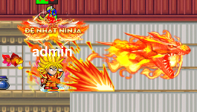

Picture 26. Level 20 skill

**Principal**

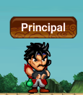   

Picture 27. Npc principal

To become a stronger ninja you need to persistently practice regularly. Doing missions is the fastest way to improve your strength. So please come see the principal regularly to receive assignments. Completing the mission will bring many attractive rewards.

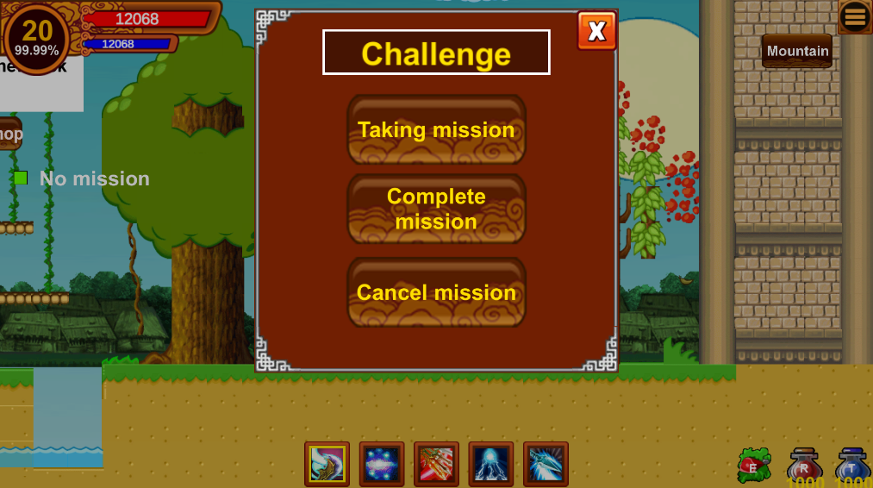

Picture 28. Mission panel

**NPC food shop**

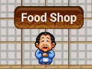   

Picture 29. NPC food shop

The shop sells food to provide mana and blood for yourself during training.

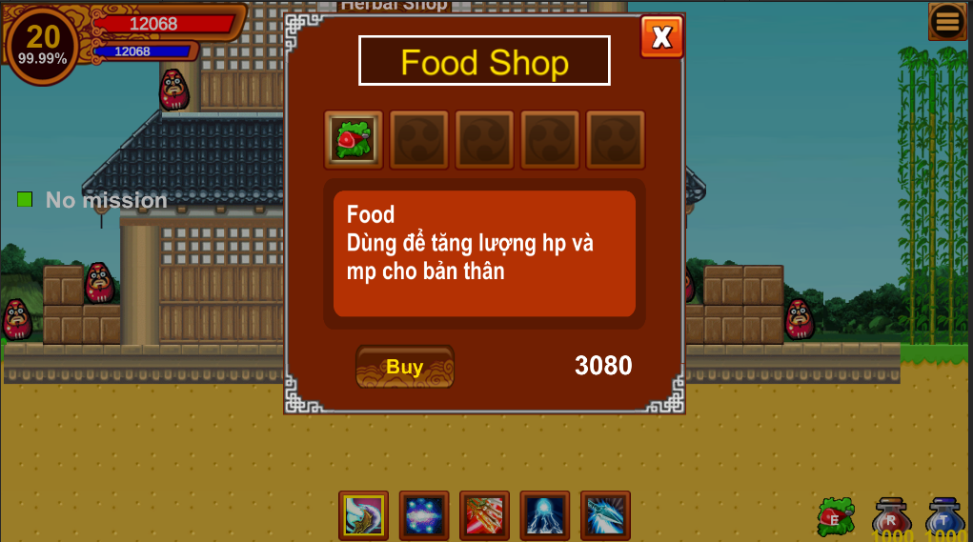

Picture 30. Food shop panel

**NPC herbal shop**

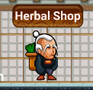  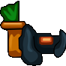 

Picture 31. NPC herbal shop

During training, you will inevitably get seriously injured. If you only use food, the recovery of mana and blood will be very slow, so go to the herbal shop to buy Hp and Mp potions to Provides more mana and health.

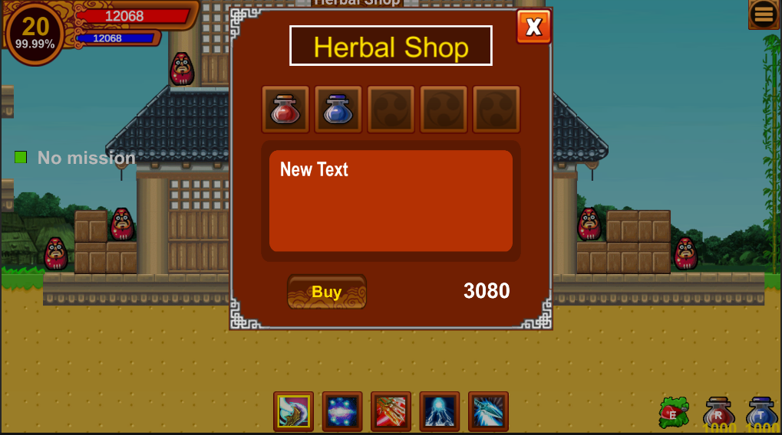

Picture 32. Herbal shop panel

**Scene Game menu**

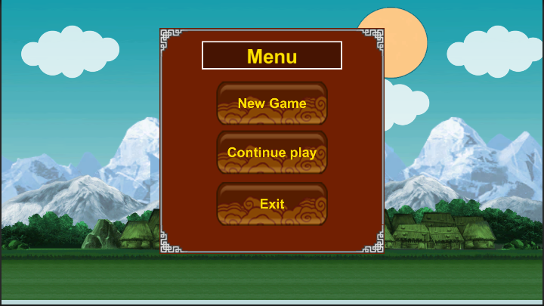

Picture 33. Scene game menu

The game's main screen is the starting point for the player and provides options for navigating the game. From here, the player can start a new game, load a saved game, or exit the game.

**Scene school**

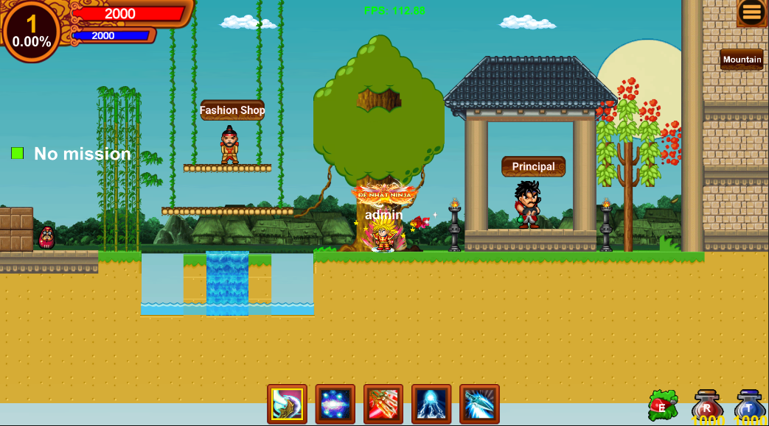

Picture 34. Scene school

The game's first map is a vast and diverse landscape waiting for you to explore. This is the school where you will practice movement skills to get familiar with the surrounding environment. Here, you will participate in training courses from principals and personal tasks. Each character will have a unique personality, your practice and behavior in the game will make you unique.

**Some other scenes.**

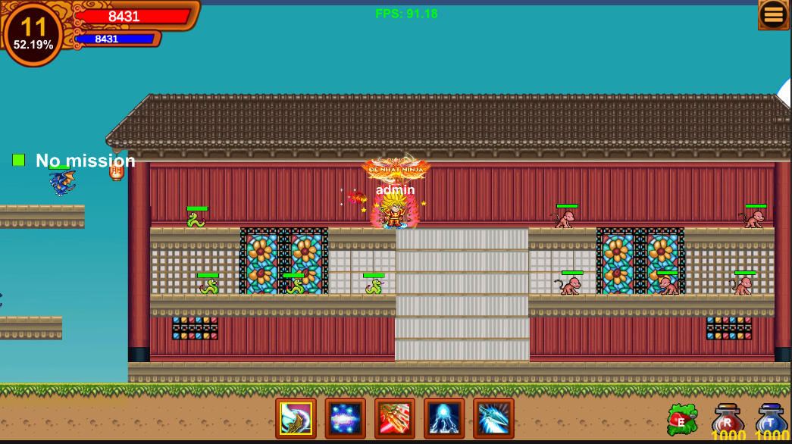

Picture 35. Scene templeA

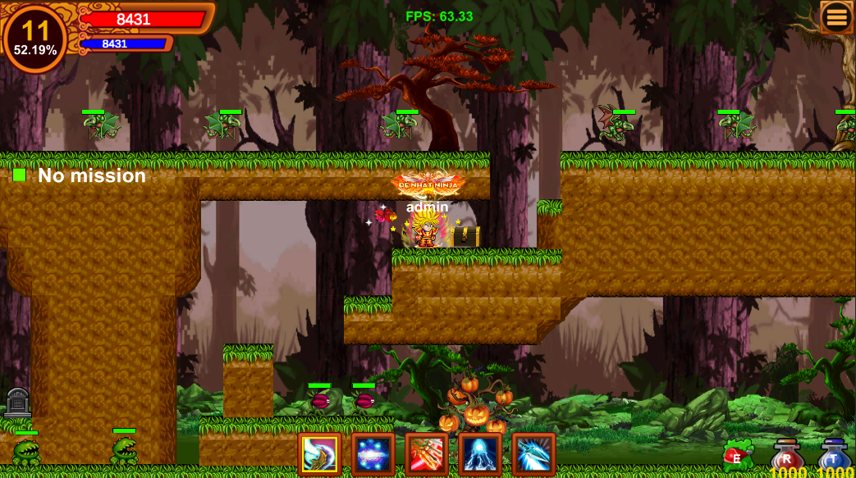

Picture 36. Legendary village scenes

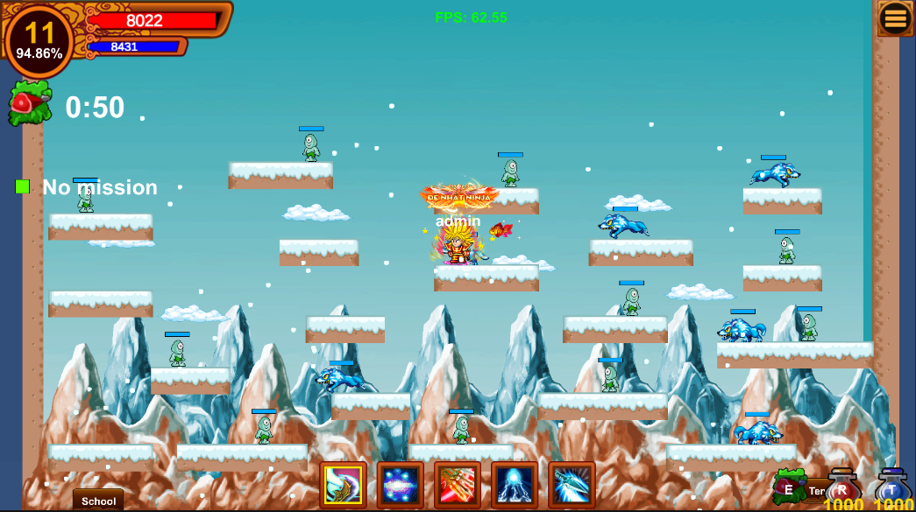

Picture 37. Ice mountain scene

**Selection buttons:** When you click on an icon, the corresponding function will appear.



Picture 38. Selection buttons

**Click button box** 

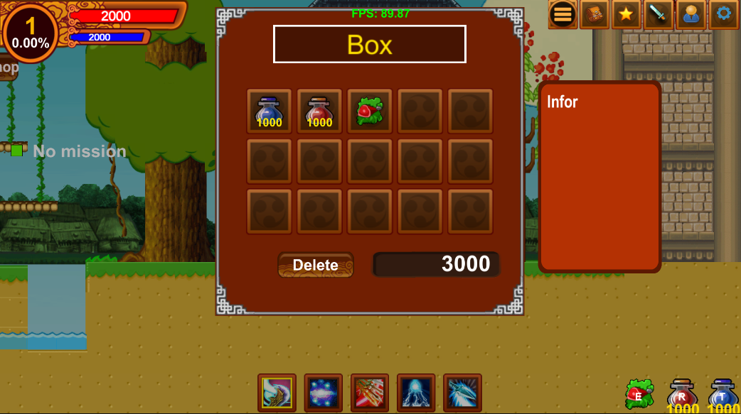

Picture 39. Luggage information panel

The inventory is where all the items like Hp, Mp, Food, etc. are stored. and there are a total of 15 storage cells. When clicking on an item, information about that product will be displayed or the item can be deleted. There is also a display of the player's coin information. Coins are used to buy items at stores or to revive on the spot when Hp=0.

**Click buton mission** 

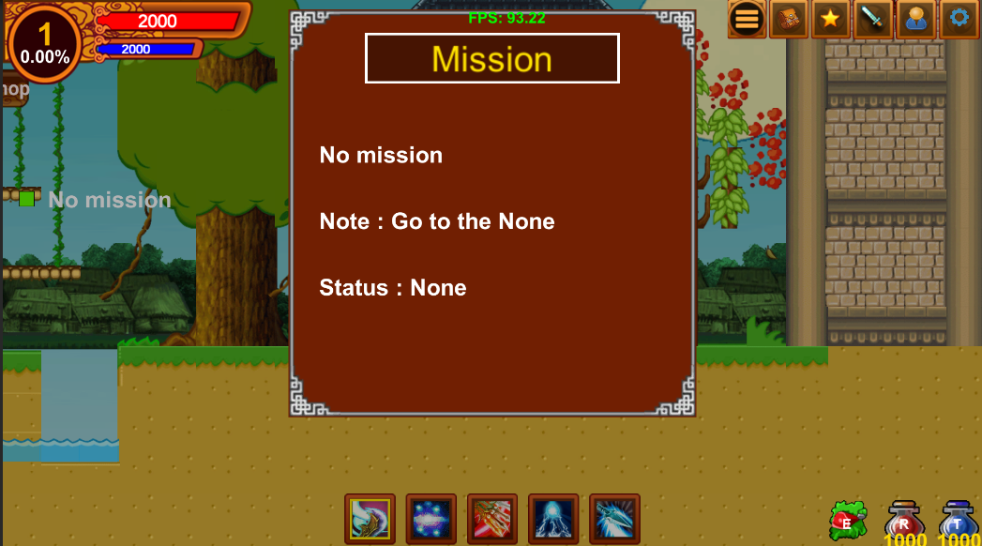

Picture 40. Mission information panel

To experience the game without being boring, players are tasked with finding the map where monsters live and destroying them. The monsters are extremely ferocious and large in number, requiring players to practice regularly. Completing the task will return to the principal to receive a reward. There is a small note that the mission needs to be done continuously throughout the game. If the player exits the game, the mission will be canceled.

**Click button skill** 

Players can capture skill information such as skill level descriptions that need to be reached to unlock skills, skill levels (each skill will be upgraded up to 3 times).

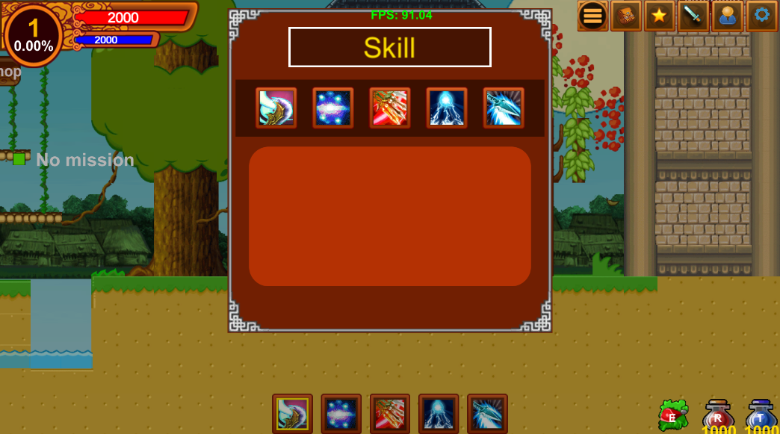

Picture 41. Skill information panel

**Click button information** 

Displays all information about the character: name, level, experience, Hp, MP, attack, wind skills, fire skills, ice skills.

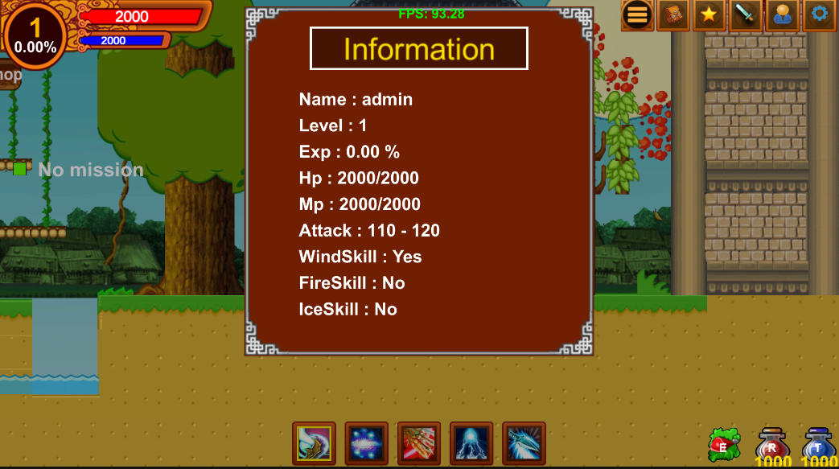

Picture 42. Player information

**Click button setting** 

This board gives players control over various aspects of the game. First, players can fine-tune their audio experience by adjusting the volume of captivating music and immersive sound effects. Second, players have the freedom to end their current gaming session or navigate back to the previous screen, allowing for seamless exploration and navigation. These comprehensive control options allow players to tailor their gaming experience, creating a personalized journey through captivating virtual worlds.

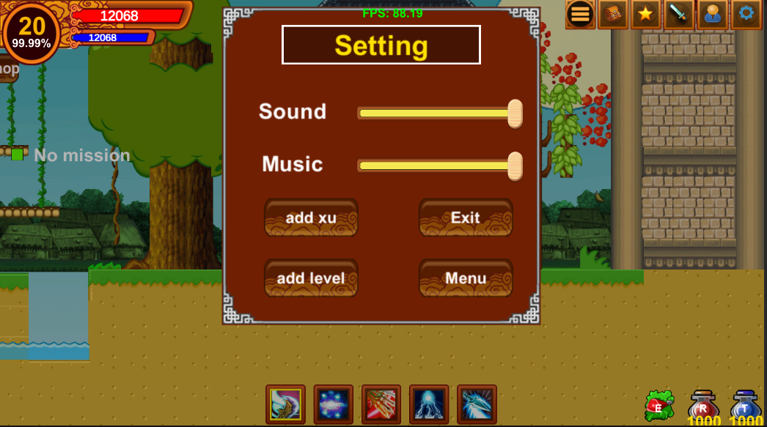

Picture 43. Setting panel

3.3 Instructions for playing games on the website

Step 1. <https://quachdai.itch.io/gameninjaschool>

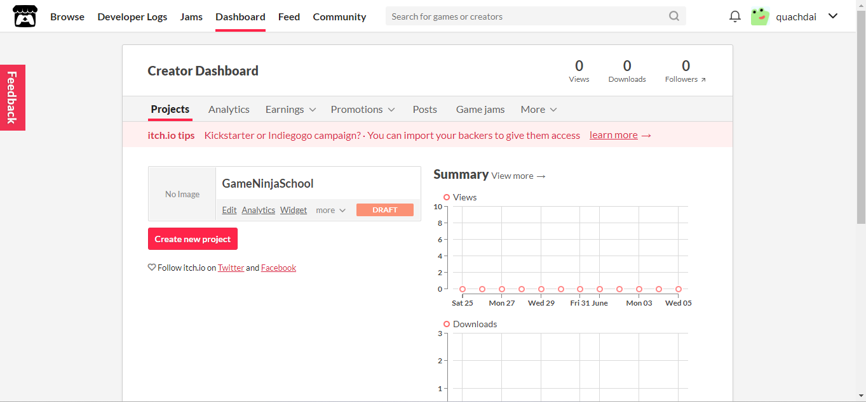

Step2. Click gameNinjaSchool

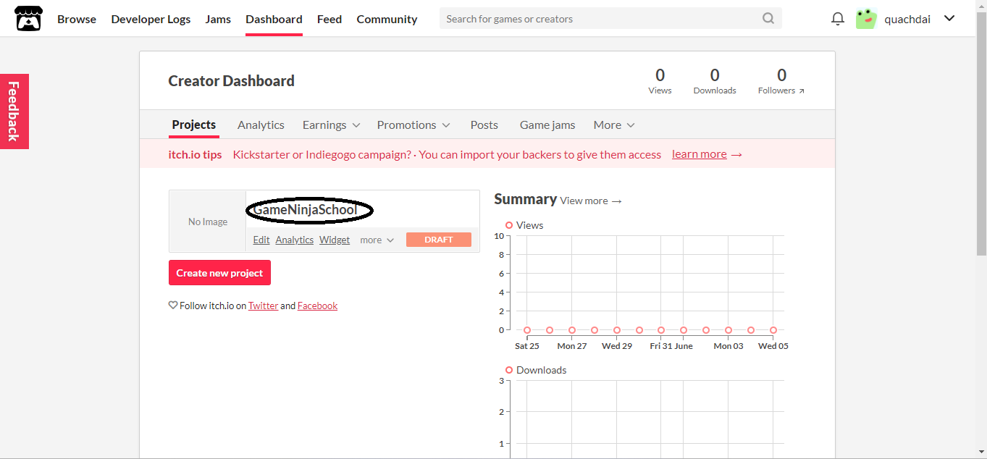

Step 3 Click Run game



# **CONCLUSION**

During the project implementation, I encountered many different challenges due to having to delve into unfamiliar areas. However, with the enthusiastic support of my advisor and myself, I completed the project on time and achieved quite good results.

* Personal skills.

- Apply the knowledge and skills that I have been trained in 4 years of studying at the University of Transport.

- Improve game programming ability, using Unity Engine,

* Product

- Successfully built games on the Windows platform

-The product has been publicly posted on the website https://itch.io/dashboard.

- Successfully built some main functions: Missions, buying and selling items, controlling characters, etc.

- Successfully built the map.

- Successfully built artificial intelligence for monsters.

However, due to the limited time frame, some parts of the project have not brought the desired results,

- The artificial intelligence component of the monster is still simple.

- The map is still simple.

- Only run games on Windows platforms.

In the future, I plan to continue to improve and expand the project to enhance its overall completeness.

- Improved artificial intelligence for monsters.

- Improved the map to make it more beautiful and added many new maps.

- Expanded many new functions: equipment can be upgraded, pets can assist in attacking monsters.

- The game can run on Android, iOS, etc.

Although it is still an idea at this stage, I believe that this development direction will achieve success in the future.

Throughout the project, I gained valuable experience in developing applications on the chosen platform. These experiences will serve as valuable assets in your future endeavors and professional career.

# **REFERENCES**

1. The C# Tutorials

<https://www.w3schools.com/sql/>

1. Image and Music

<https://drive.google.com/file/d/14po9uQ_45uCTlc4Tip8TRZcY8fCXs625/view?usp=sharing>

1. Engine Unity tutorial

<https://docs.unity.com/>

1. Dotween tutorial

<https://dotween.demigiant.com/>

1. Asset

<https://assetstore.unity.com/>